1. Goto this web site: <https://www.anaconda.com/distribution/>
2. Click the download button on the page:



1. Download Python 3.7 version, 64-bit.

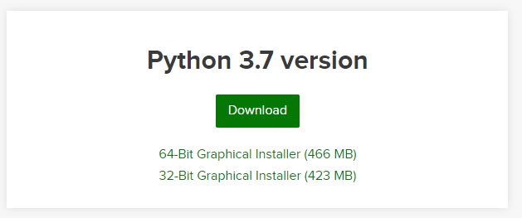

**Note:** Just install the Anaconda package, it will include all the Python 3.7 executables, libraries and tools, which means you don’t need to install a standalone Python again.

1. Run Anaconda Navigator.

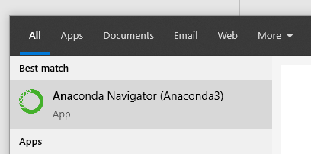

1. Launch Jupyter Notebook from the navigator.

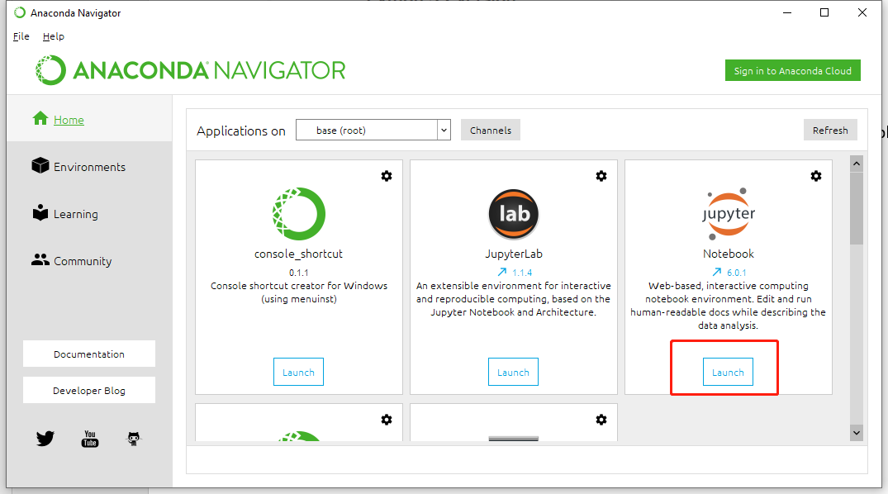

1. Jupyter Notebook is a web-based tool, it will automatically open a webpage from your default web browser.

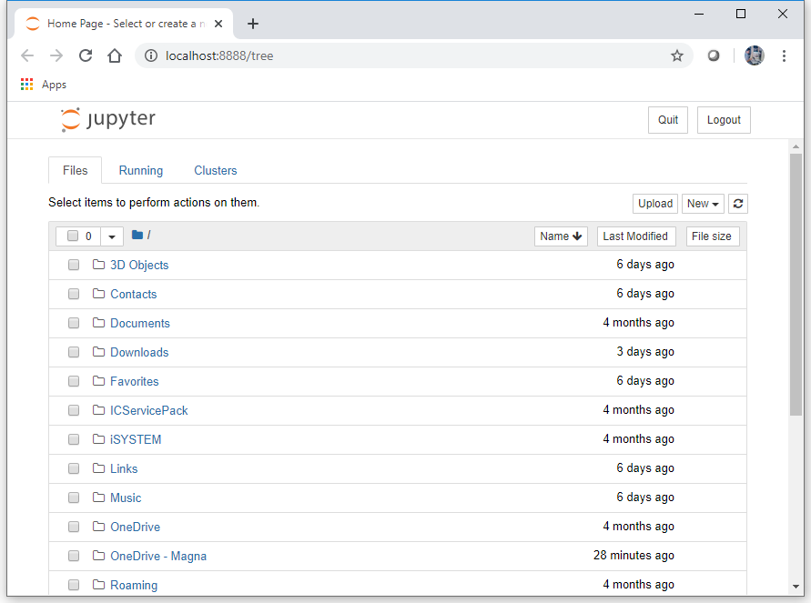

1. The webpage will looks like a file system, you can navigate to the location where you save the script file (a .ipynb file).

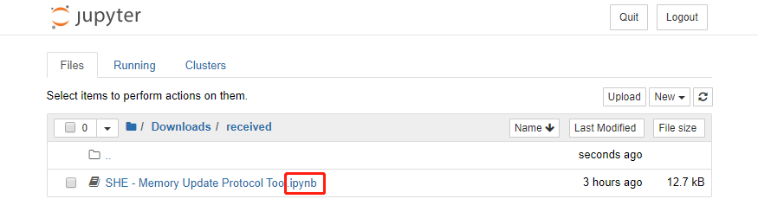

1. Click the file name to open the script. It will open a new page that contains the script which is able to run. Click **Cell🡪Run All** every time when you update your input.

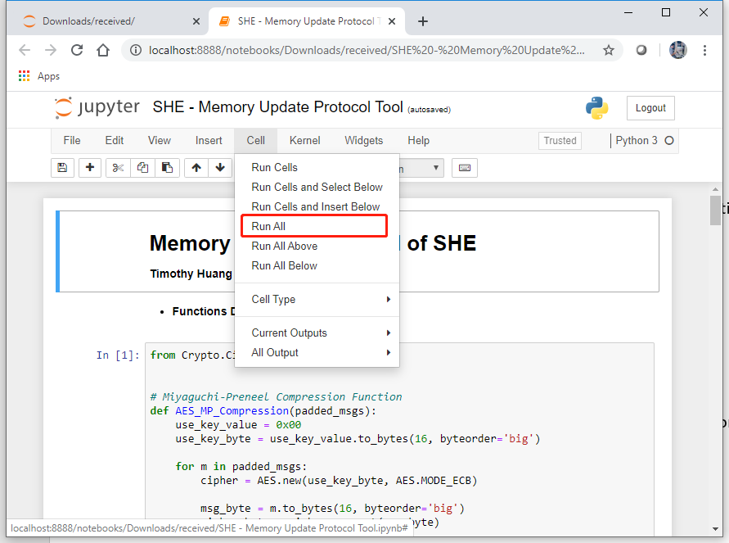

1. To modify your input, goto cell 3 with the title – Input Value Pending Change.

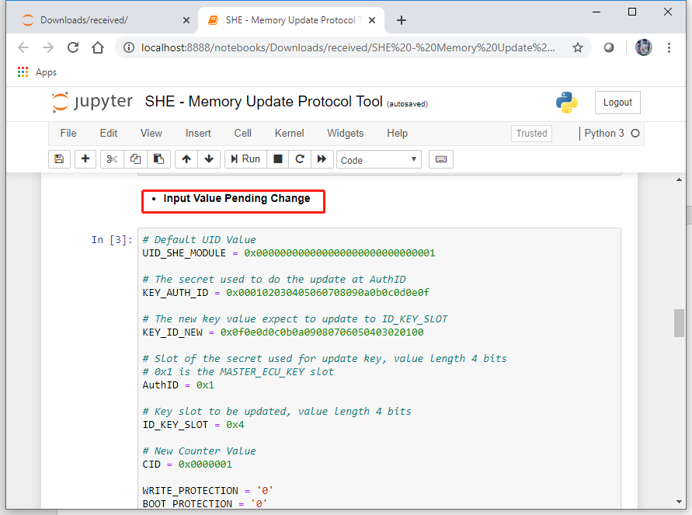

1. To view your M1 to M5 result, goto cell 10 with the title – Format Print M1 to M5.
2. Copy paste the M1 to M3 values line by line to CANoe for ***RID 0x1010*** and start the routine.
3. Run request result to get M4 and M5 from the ECU and compare if the values are the same as the output from the script.

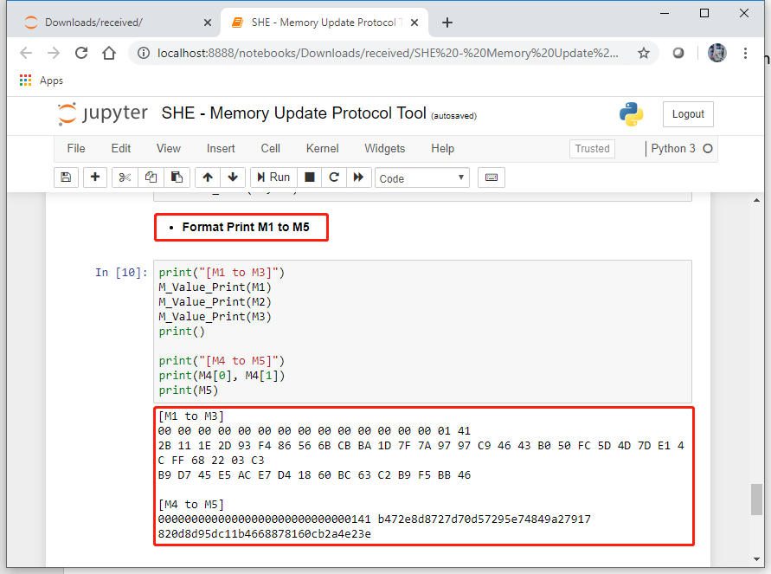

1. The script under title – Collective Verification for Multiple Slaves, is for ***RID 0x100F***.

You are only allowed to modify cell 11 for the random number.

